

Lab Title

**4b**

Programs: Computer Engineering

|  |  |
| --- | --- |
| Course Number | **COE608** |
| Course Title | **Computer Organization and**  **Architecture** |
| Semester/Year | **Winter 2020** |
| Instructor | **Nagi Mekhiel** |

**Lab Report No.**

**Data-Path Design**

|  |  |
| --- | --- |
| Section No. | **04** |
| Group No. |  |
| Submission Date | **03/10/2020** |
| Due Date | **03/10/2020** |

|  |  |  |
| --- | --- | --- |
| Name | Student ID | Signature* |
| Duanwei Zhang | *500824903* |  |
|  |  |  |
|  |  |  |

*\*By signing above you attest that you have contributed to this submission and confirm that all work you have contributed to this submission is your own work. Any suspicion of copying or plagiarism in this work will result in an investigation of Academic Misconduct and may result in a “0” on the*

*w ork, an “F” in the course, or possibly more severe penalties, as well as a Disciplinary Notice on*

*your academic record under the Student Code of Academic Conduct, which can be found online at:*

[*www.ryerson.ca/senate/current/pol60.pdf*](http://www.ryerson.ca/senate/current/pol60.pdf)*.*

# R egister32.vhd

1. 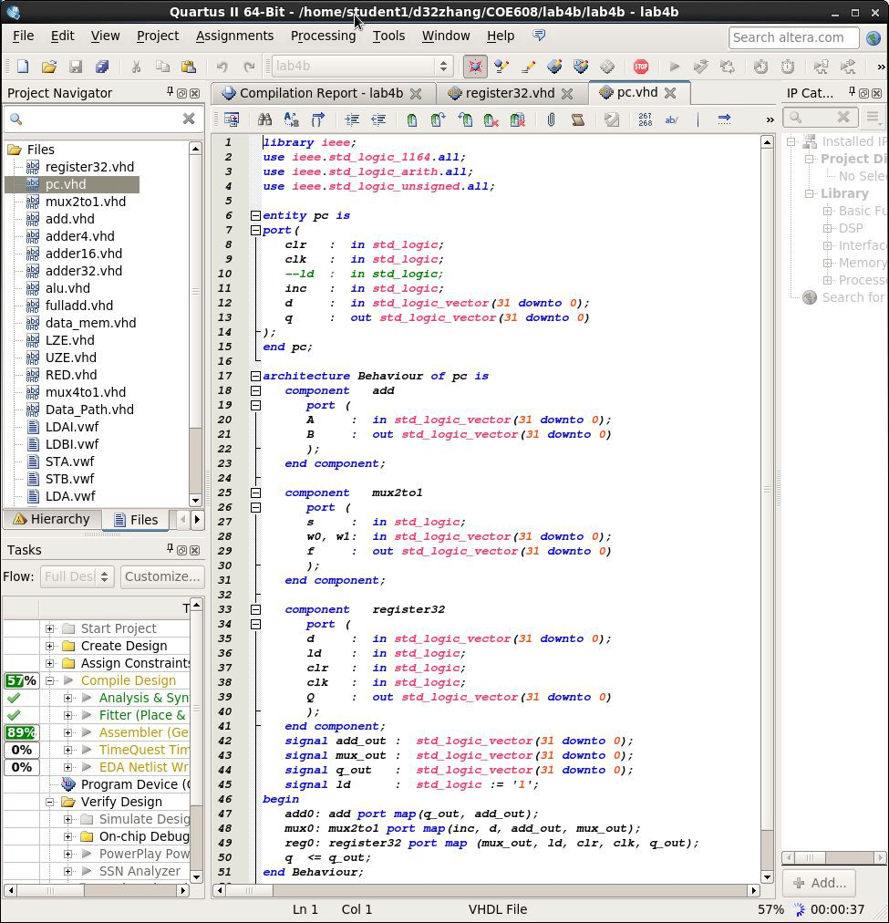P c.vhd
2. 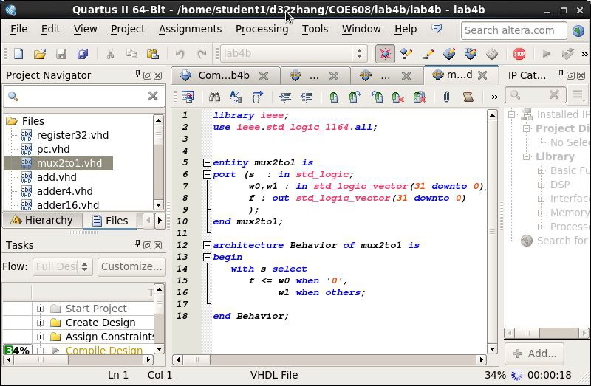M ux2to1.vhd
3. A dd.vhd

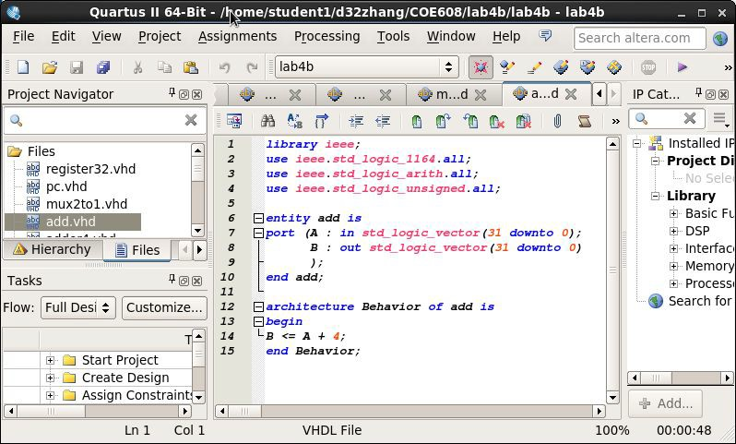

1. 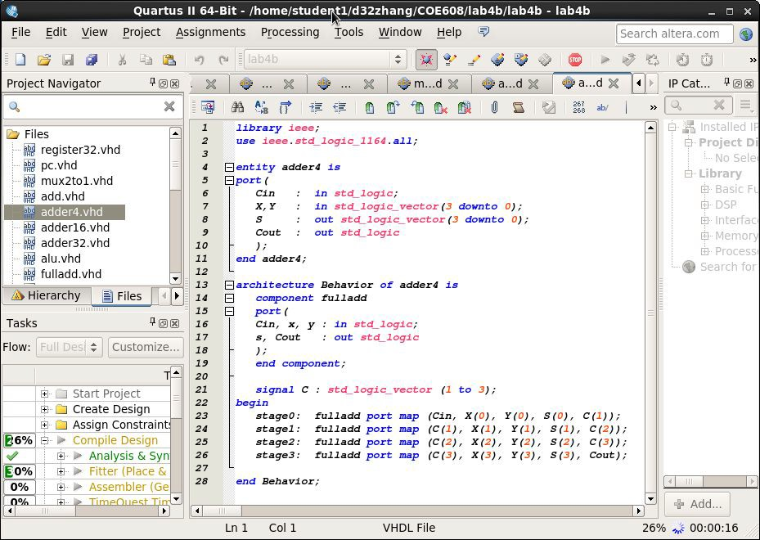A dder4.vhd
2. 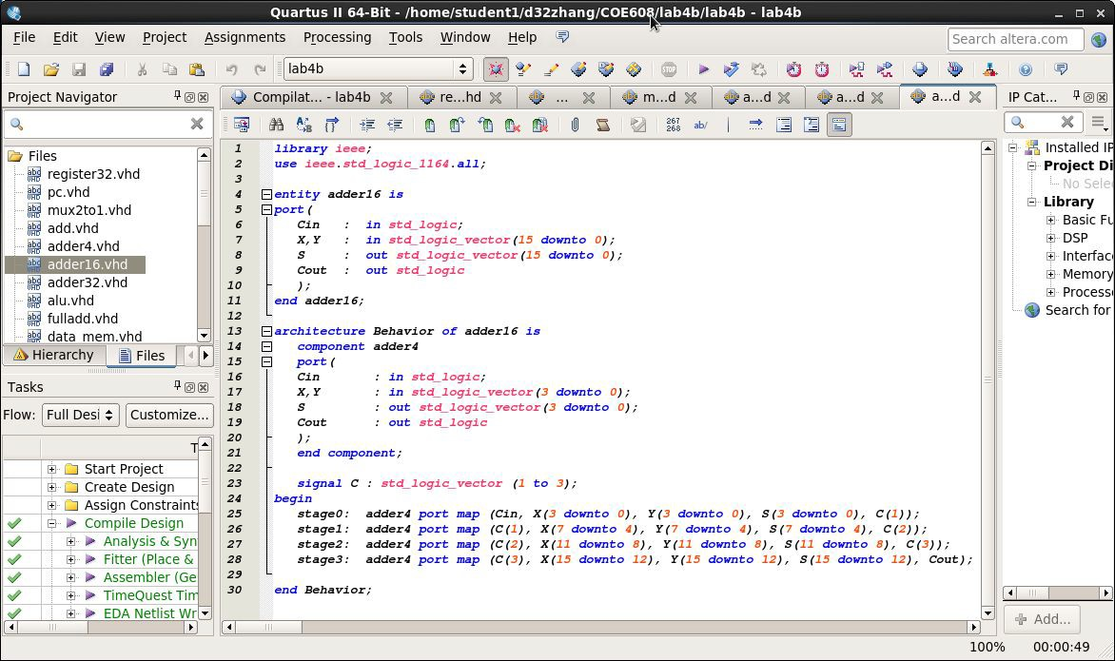A dder16.vhd
3. 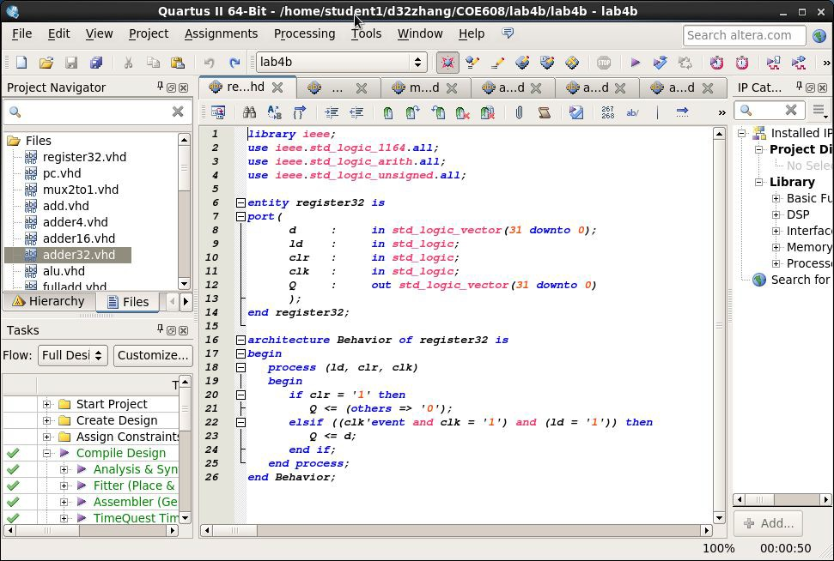A dder32.vhd
4. A lu.vhd

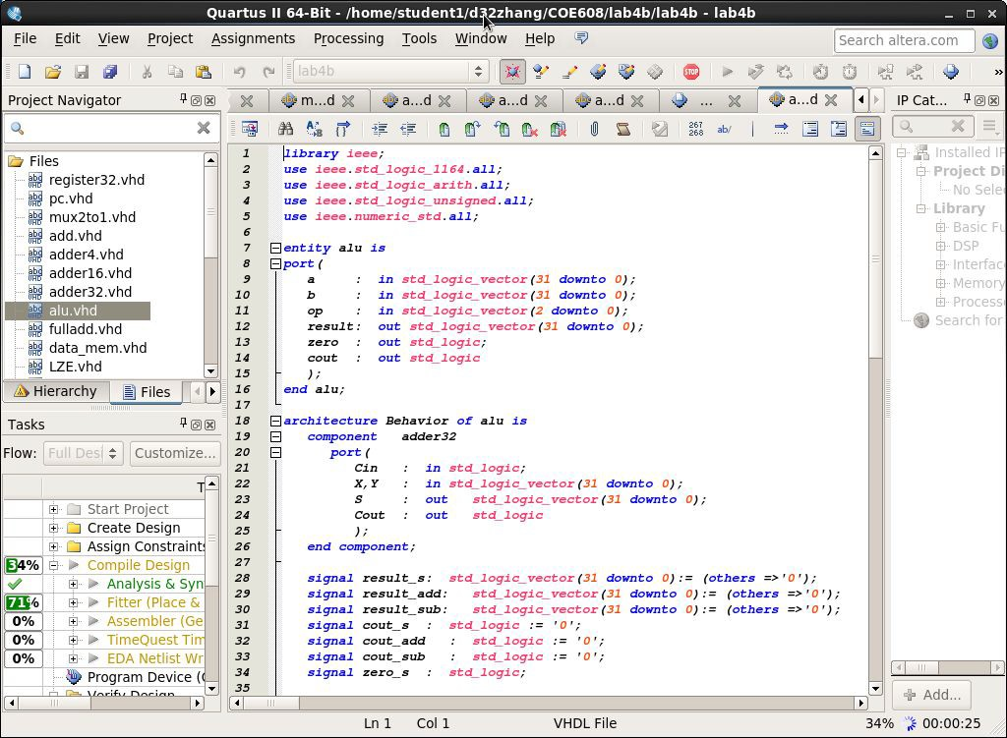

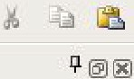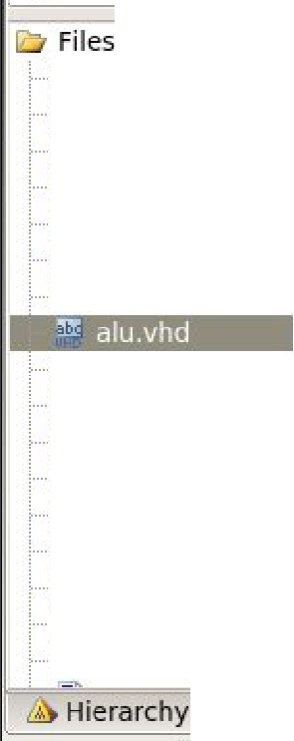**Quartus** II **64-Bit** - **/home/ st uden tl / d 2zhang /COE608 /lab4b /lab4b** - **lab4b** _ □ **x**

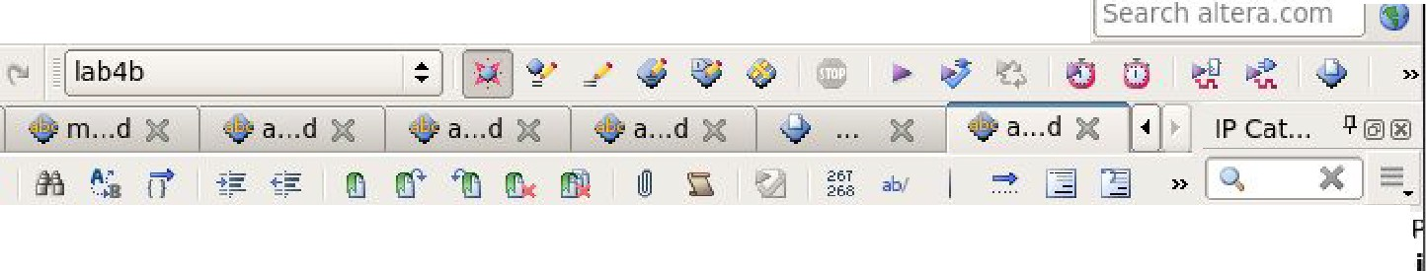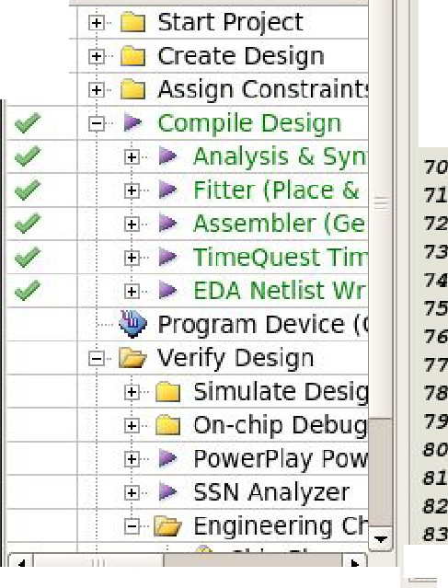

s1gnmen ts Processing Jools '!'i,'maow !::!elp '9

")

)(

'- -,- - - - - - - - - - - - - - - - - - - - - - - - - - - - - - - - - - - -,.= $-

*3!!,*

*36*

*37*

*38*

*33*

***40***

***41***

***42***

***43***

***44***

***4!!,***

***46***

***47***

***48***

***43***

**.50**

**.51**

**.52**

***.53***

**.54**

***.5!!,***

**.56**

**.57**

***.58***

**.53**

***60***

***61***

***62***

***63***

***64***

***6!!,***

***66***

**67**

***68***

***begin***

***a.ddO***

***sub 0***

·

**Ins ta lled** I

**8 Project D**

***adder32 port map {op {2).,* a, *b , r e8 ul t _ add ., cout _ add ) ;***

**a dder3 2 *port map (op( 2).,* a, not**

***b., result _sub., cout_sub);***

8 **Library**

: •· ele

El

I

El

***process (a., b , op)***

***begin***

***case{o p ) is***

***when "000"*** *=>*

***res ul t _ s <=* a and *b ;***

***cout _ s <=* ' o** ';

***when "00 1*** rl *=>*

***resul t_s <=* a *or b; cout_s <= ' 0*** ';

***when "0 10 "*** *=>*

***r e sul t _ s <= r esul t _add ;***

***cout _ s <= cout _ a dd ; when "0 11 "*** *=>*

***re sul t _ s <= b ;***

***c o ut _ s <=* ' 0** ';

***when "110"*** *=>*

***re sul t _s <= r esul t _sub ;***

***cout _ s <= cout _ sub ;***

**when *"1 00 "*** *=>*

***r e sul t _ s* ¢:: *a.( 30 downto 0 ) c o ut _ s <= a. ( 31 ) ;***

***when "1 01*** rl *=>*

llJ· Basic f

llJ DSP

llJ l nte rfac

© Memor llJ Process Search for

***' 0 ' ;***

***r e sul t _ s <=* '0' *a.( 31* downto *l ) ; cout _ s <=* ' o** ';

**when *others*** *=>*

***r e sul t _ s <= a.;***

***cout _ s <=* ' O** ';

**end *ca se ;***

El ***case ( r e sul t _ s ) 1s***

***when ( ot he r s =>* ' O** *') =>*

***ze r o _ s < = ' 1*** ';

**when *others*** *=>*

***ze r o_ s <=* ' o ' ;**

**end *ca se ;***

**end *p r ocess ;***

***r e sul t <= r esul t _ s ; cout <=* cout_ *s; zero <= zer o_ s;***

***end Behavi or ;***

... - - 11 -

- - - - - - - - - - - - - - - - - - - - - - - - - - - - - - ,

l"=='= =='== ="== = = = ="'='_J

l•I Ill

T- l I + Add ...

l •I

|  |  |
| --- | --- |
| file _!;d 1t 1e w frOJect {\s  : □  Project Navigato r | |
| 0. **X** | |
| reg ister32.vhd pc.v hd  m ux 2tol .vhd  ii\a add. vhd  adder4 .vhd  ii\a adde rl 6.vhd  adde r32.vhd  fullad d.vhd  dat a_mem .v hd LZE. vhd  UZE.vhd RED.vhd  mux4tol .vhd  ij Data_Path .vhd LDA l.vwf LDBl.vwf |  |
| Files ◄ | ► |
| Tasks \l @l l!!J  Flow : I Full Desi 11 Customize.., I | |

100% 00:00:53

# F ulladd.vhd

1. D ata_mem.vhd

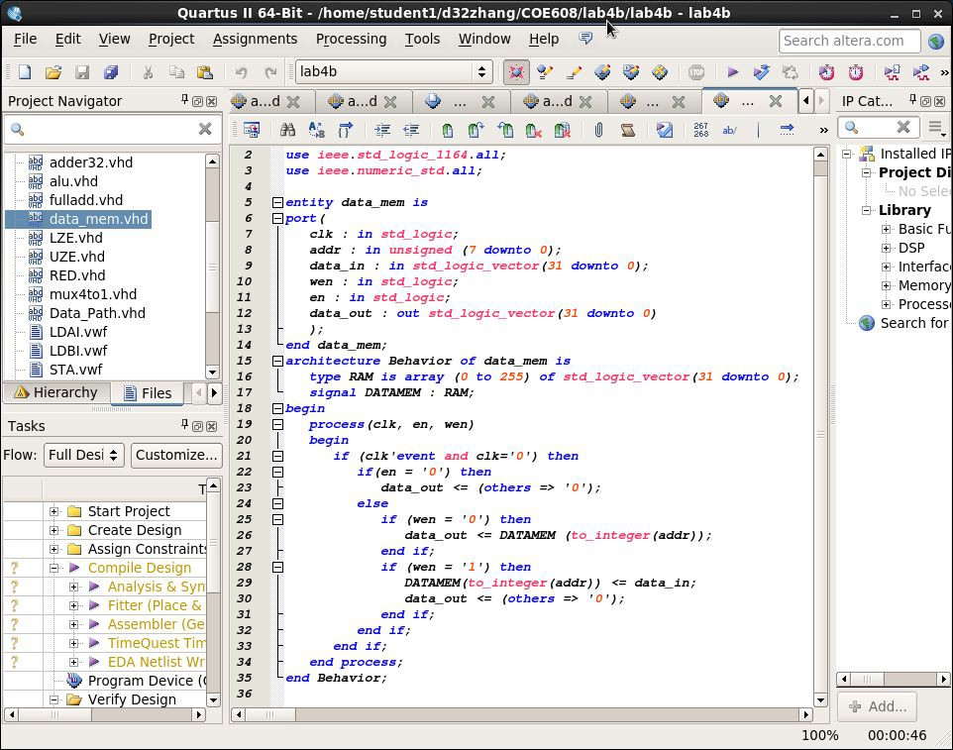

1. 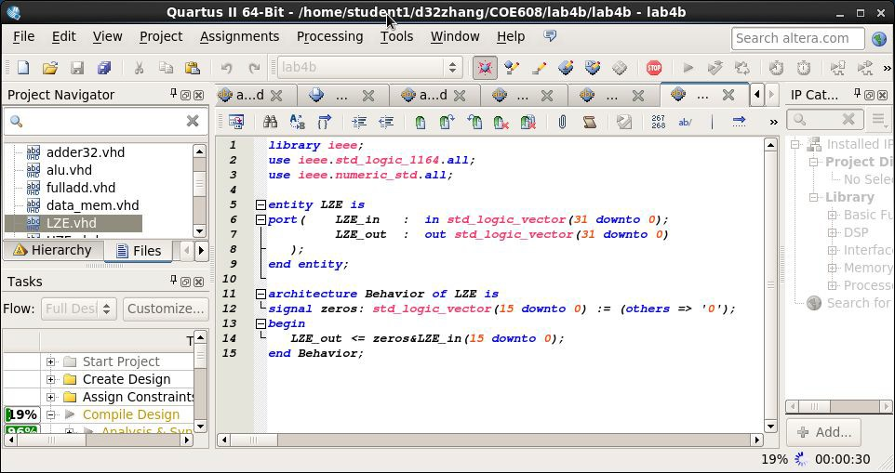L ZE.vhd
2. U ZE.vhd

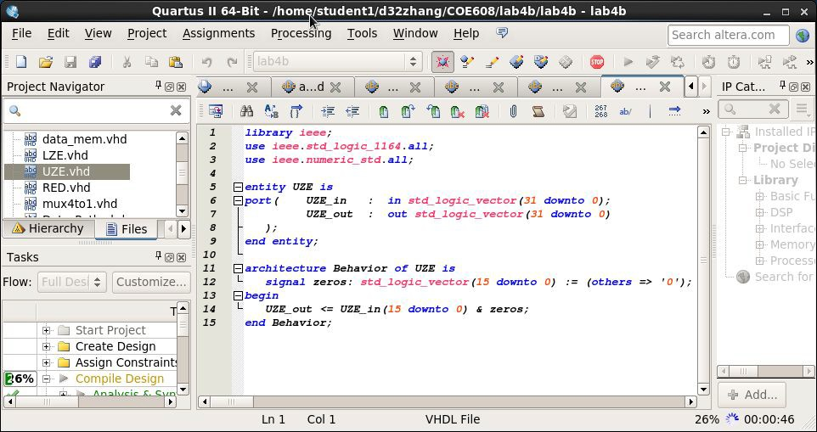

1. 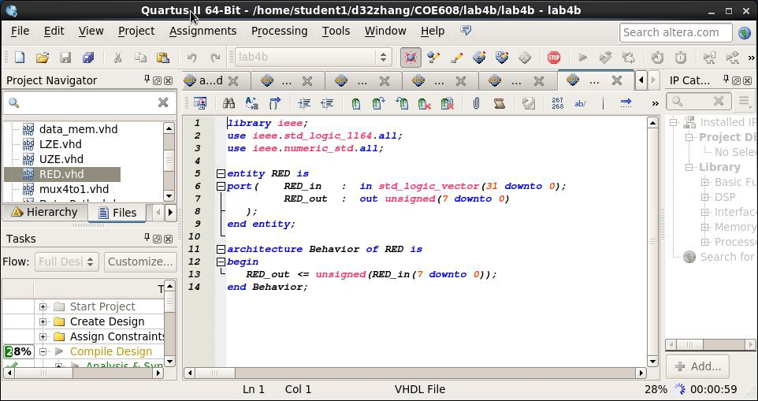R ED.vhd
2. M ux4to1.vhd

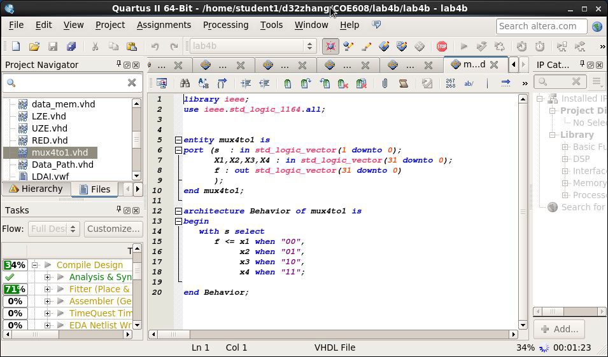

1. 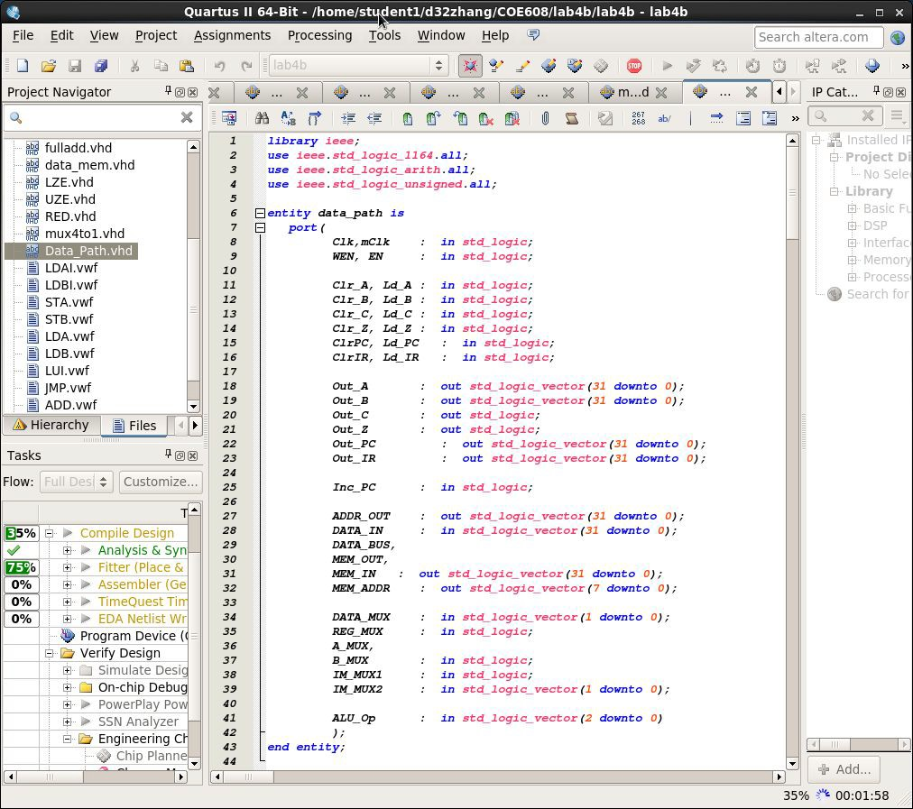D ata_Path.vhd

**1,t** Quartus

II **64-Bit** - /home/studentl/d32zhang/COE6 8/lab4b/lab4b -

f ile !;dit '\,"ie w roject ssign men ts Process ing Iools ),','i ndow !:!elp @;I

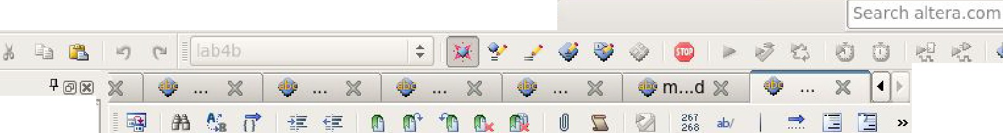

Project Nav iga"tor

lab4b _ □ **x**

I P Cat ... I' @JOO

**X** I *J,*--**x**-I =.

:==:i;i\;;2:=fu=l al= =d =d. =v=h =d= ======== :;;;;;l **,-- 1-4 ---.L- - - - - - - - - - - - - - - - - - - - - - - - - - - - - - -, =.** El ln talled Ir

.. m da ta_m em. v h d • *E] arc h i t ec t ur e Behavior of Data_path 1s* $·· **Project D**

lffili' *16* El *component dat a_mem is* No Sele

·· m

LZE. vhd ***17*** El *por t /* El **Library**

, ii\ij UZE.vhd ***18*** *elk in " td _ l <>9"i e ;*

m..

RED. v hd *,,* a.ddr *in* un.sig-ncd *( 7 downto OJ ;* $· Bas. F

--m mux4tol.vhd .50 *dll t a_ .in in s td _ .l ogi c_ v ect or ( 31 downto* OJ ; $· DSP

*31 wen in s t d _ l ogi c ;* [B. lnte f *c*

iles ◄ ►

. lll!!JData_Path vhd

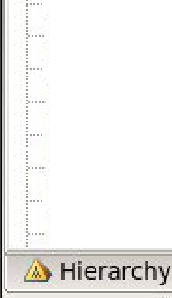LDAl.v wf LDBl.vwf

*32 en in* s t d _ l ogi c ; $· Memori

1. *da t a_ out out Jll't d _ .l ogi c_ v ect or ( 31.* downto OJ [±I Process

*34 1*

STA.vwf STB.vwf

.5 end *c om; pon en t ;*

***.56***

* + Search for

LDA. vwf

* 1. El
  2. El

*component register32 is*

*port (*

LDB.vwf LUl.vwf JMP.vwf ADD.vwf

f

Tasks \I @)@

Flow: ! I Customize...

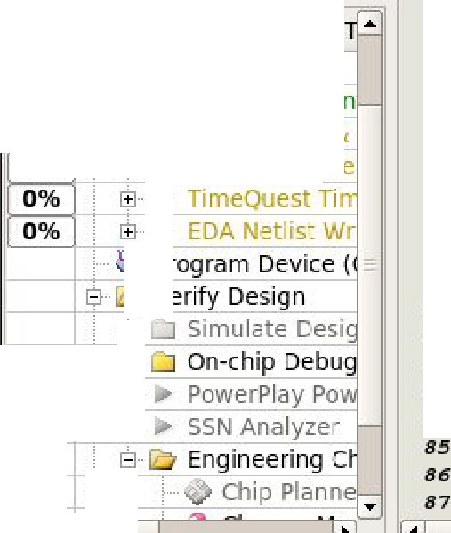

I JE-5,% El ► Comp ile Design **W o** ► Fitte r (Place & **0%**

►

► Assembler (Ge

© ► Analysis & Syn

***5!1***

***60***

***61***

***62***

***63***

***64***

***6!S***

***66***

**67** El

***68*** El

*6!1*

*70*

7l

72

*73*

***74***

7.5

*76*

**d**

*id* elr ***elk Q***

*};*

end *c ompon en t ;*

*component pc is*

port *(*

elr ***elk*** *inc*

**d**

***q***

*}* ;

end *componen t ;*

*in std _logic _ vector (31* downto OJ ;

*.in • t d _ .l ogi c- ; in s t d _ .l oq i c ; in s td _ .l ogi c ;*

*out std _logic _vector (31* downto *0)*

*in s t d_ l ogi c ; in s t d_ l o gi c ; in s t d_ l o gi c ;*

*in std _logic _vector (31* downto OJ;

*out std _logic _vector (31* downto OJ

77

►

*78*

7!1

*80*

$ ··

*81*

©

*82*

IE··

*83*

***84***

©

B

El *component* ***LZE is***

El *por t ( L ZE_ i n LZE _ out*

*} ;*

t

end *c o mpon en t ;*

El *component* ***UZE is***

El ***port*** *( UZE_ i n UZE_ out*

*}* ;

in *std _ logic _vector (31* downto OJ;

*out std _.logic _ vector ( 31 downto* OJ

*in st d _ l ogi c _ v ec t or ( 3.l downto* OJ ;

*out std _ logic _ vector ( 31 downto* OJ

l •I II I l •I

1"- ,_ _

,

.;,..._ ...,,- - - - - d. d_ _J

II

. ,_- -end - *c om*-*pon e*-*n t ;*- - - - - - - - - - - - - - - , I + Add..,

35 % ,,;, 00:02:21

Ill

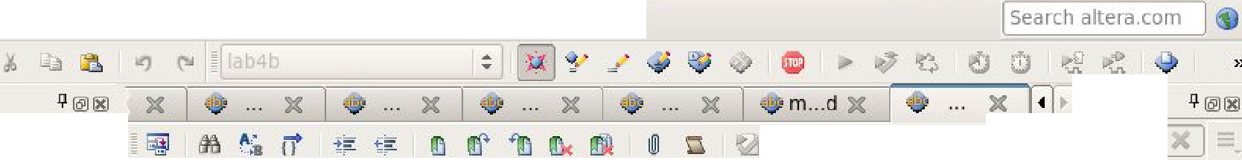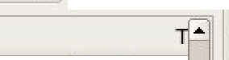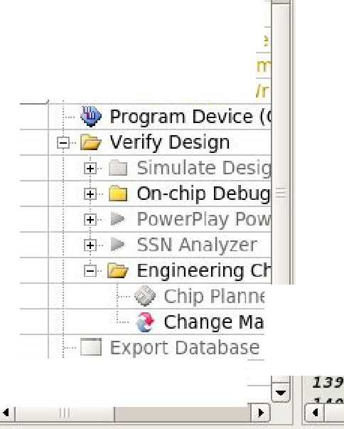

f ile _!;dit '\,"i ew

:o

Project Navigator

a.

i§a adder32 .vhd

i§a alu.v hd

j§a fu l lad d.vhd

Quartus II **64-Bit** - /home/ stu de

_!:'r eject !'o,ssignments Processing I ools

l /d32zh an g/COE60B/l ab 4b/l ab 4b - lab4b

indow !:!elp '9

_ □ **x**

**X**

**X** g ab/ --

§

·

·

·

·

··

-

data_mem .vhd LZE. vhd UZE.vhd RED.vhd mux4tol.vhd

ffLil Data_Path vhd LDAl.vwf LDBl.vwf

- STA.v wf

* STB.vwf

***88***

***89***

***!/0***

***91***

***92***

*!/3*

***94***

***!l!l***

***!/6***

!17

***!/8***

***!/9***

*100*

*101*

*102*

*103*

***104***

***lO!l***

*106*

*107*

*108*

*109*

*110*

f-

El

***component RED is***

IP Cat...

1 -,,

B ***.l'o*** ln IJlled Ir

8 **Project o·**

***port (***

1

***RED_ i n RED_ out***

***in* s t d_ l og i c_ *vector (31* downto *OJ*** *i*

·

No Sele

***out***

**un.signed *( 7* downto *OJ***

*) ;*

**end *co mpo nent ;***

El

1

***component mux2tol is***

***port (s : 1n*s t d_ l og1c;**

**wO,w.l *:* in *• t d_ l og .ic _ vect or ( 3l.* downto OJ;**

***f :* out *st d_ l og i c _ vect or ( 3l* downto OJ**

*)* ;

***end* c omp onen t ;**

B **Library**

l±l Bas - f1

SD5P

Ill ilter' IB- emor, Ill Process

<,earch for

El

··

·

··

LDA.vwf LDB.vw f LUl.11wf JMP.vwf ADD.vwf ADD l.vw f

1

***component mux4tol is***

***port (s : in •td _logic_vector (l downto* OJ ; *Xl,X2,X3,X4 : in st d_l ogic_vector ( 31 downto* OJ; *f :* out *st d_ l og i c_* vector *(31* downto *OJ***

*) ;*

***end component***

***;***

, ··

L.

El El

***component: s.lu is***

**port** *(*

Flow:

I %

j Custom ize... *116*

*117*

*118*

***cout***

*);*

**end *comp onent ;***

**out *st d_ l og i c***

I ,

- ► Compile Design

1B ► Ana lysis & Syn

**0%** 1B ► Assembler (Ge

$ ► Fitter (Place &

***;***

**0%** $ ·► TimeQuest Ti

**0%** l±J..► EDA Netlist Wr

*136*

:.... □ Archive Project

*137*

*138*

**.st d_ l og.ic _ vector *( 31* downto *OJ: st d _ l og i c _* vector *(3l doJimto OJ ;***

* ***t d _ l og .ic _ vect or ( 31* downt:o OJ ;**

***st d_ l og i c_ vector (31* downto *OJ: s.ignail ALU_ out* .8't d _ J.og i c _ ve c t or *( 31 downto 0 )*** *i* ***signal zer o_:fl.ag : • t d_ l ogi c ;***

***signal car ry_r l ag : .9't d _ l ogi c ;***

***signail temp***

***st d _ l ogi c _ vect***

***or ( 30* downto *OJ*** . -

***( ot her5***

***= > ' O*** ' J ; ....

'"

l •I II I

+ Add...

l •l

36% ,::, 00 :0 3:03

|  |  |  |  |
| --- | --- | --- | --- |
|  | *132* | ***signal*** | ***UZE_ I H_ HUXl _ out*** |
| *133* | ***signail*** | ***I H_HUXl _ out*** |
| Chip Planne | *134*  *13!!* | ***signal***  ***signal*** | ***LZE_ I H_ HUX2_ out***  ***I H_HUX2_ out*** |

|  |  |  |  |
| --- | --- | --- | --- |
| @ Hierarchy | *111*  Files ***4*** ► *112*  *113* | ***b***  **op** | **i.n .8't:d_ l og.ic _ ve c t:or *( 31* downt:o *0 )*** *i*  **.i.n .8't d _ l ogi c _ ve c t or *( 31 downto* OJ ;**  ***in* .9't:d_ 1og i c_ ve c t:or *( 2 downto OJ:*** |
| Tasks | *114*  *ll!l* | ***r esul t: :***  **zero** | ***out st d_ l ogi c_* vector *(31 dokmto OJ*** *i*  ***out st d_l ogi c;*** |

|  |  |  |  |
| --- | --- | --- | --- |
| *119* |  | | |
| *120* | ***signs.l*** | ***I R_ OUT • t d_*** | ***l og.ic _ vect or (31 downto 0 )*** *i* |
| *121* | ***signal*** | ***cfat a_ bus _ s -"t d_ l ogi c_ vect or ( 31* downto OJ;** | |
| *122* | ***signail*** | ***LZE_ out _ PC .!!*** | ***Jtd _ l ogi c _ vect or ( 31* downto *OJ*** *i* |
| *123* | **s.ignail** | ***LZE_ out:_ A_ Mtix*** | **Jl't:d_ l og i c_ vector *(31* downto *OJ*** |
| *124* | ***signal*** | ***LZE_ out _ B_ Mtix*** | **s t d _ l og i c _ *vector (31* downto *OJ;*** |
| *12!!* | ***signail*** | ***RED_ out _ Dat a_ Hem*** | ***unsigned ( 7* downto *OJ ;*** |
| *126*  *127*  *128*  *129* | ***s.ignal signail s.ignail***  ***signal*** | ***A_Mux_ out* Jll'td _ l og .ic _ ve c t:or *( 31* d'ownt:o OJ ; *B_Mux_ out Jll'td _ l ogi c _ vect or ( 31.* downto *OJ ; r e g""_ A_ out st d _ l ogi c _ vect or ( 31* d'ownto OJ ;**  ***reg_B_out Jll'td _ l ogi c _* vector *( 31* d'ownto *OJ ;*** | |
| *130* | ***signail*** | ***r eg_Mux_ out*** | ***st d _ l og i c _ vector (3l* downto *OJ;*** |
| *131* | ***signal*** | **cfa ta_ mem _ out** | **s t d _ l og'i c _ vector *(3l downto OJ;*** |

**Quartus**

;::;:;:

sig

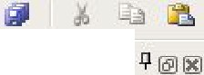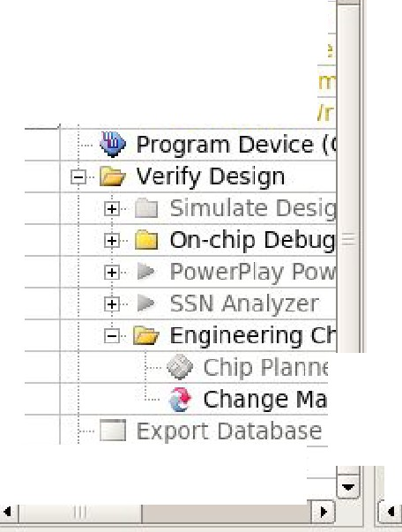

f ile _!;dit '\,"i ew

:o

Project Navigator

a.

_!:'r eject

!'o,s nments Processing

.,

)(

'. mi **:a rt**

I ools

indow !:!elp '9

**X**

IP Cat... 1/- [!!1

**X**

;;;;;a:=d=d=e=r =3 2=. v==h= d ========

*14*-*2* - I -*- _1>_e_ci; n- - -*

+:- •=-

*- - - -*

t1f

*- - - -*

Ilk

*-*

@ n

m ab/

...

§

I *,.),* **X** I =-

*-*

*-*

*-*

*-*

*-*

*-*

*-*

*-*

*-*

*-*

*-*

*-*

*-*

*-*

*-*

*-*

. a lu. v h d

*= =='"'* B ***J'o*** ln IJlled Ir

8 **Project o·**

. No Sele

B **Library**

. **LZ.E v h d**

. UZ E. v hd

. RED. v h d

.. mux4tol.vhd ffLil Data_Path vhd

LD Al.vwf

LD Bl. v w f

*143*

*144*

*145*

*146*

*147*

*148*

*14,*

*150*

*151*

*152*

*153*

*154*

*155*

*156*

El

*IR : rec;ister32 port* ***mop {***

***da t a _b us _ s ,***

s6' ful ladd.vhd

LJ *IR*

* data_mem .vhd

lirW

- '

*Cl r I ,R*

***Cl k ,.***

$ ·· **Bas-**

$ D5P

llJl 7 te r'

**F1**

E**-l**l

*I_R OUT*

;J

*LZE_ P c :*

*; E*

*) ;*

*LZE*

*port m•pI*

-

*_P c*

©· emor, IH Process '>earch for

- STA.v wf

El

***PCO: PC* port *ID11p*** *(*

@ Hierarchy

Fi les • ►

*165*

*166*

*167*

*168*

*15,*

*170*

*171*

*172*

*173*

*174*

*1 7 5*

*176*

*177*

*l 78*

*11,*

*180*

*181*

*182*

*183*

*184*

*185*

*186*

*187*

*188*

*18,*

*190*

Hl

*192*

1

***I R_ OUT ,.***

***LZE _ out _ A_ Mux***

*)* ;

Tasks Flow:

I %

j Custom ize...

I ,

- ► Compile Design

1B ► Ana lysis & Syn

1

***A_ M1Jx0 mux2tol port mnp*** *(*

***A_ MUX ,.***

***da t a_ bus _ s ,. L ZE_ out _ A_ Mux ,. A_ Mux_ out***

*) ;*

El

**0%** 1B ► Assembler (Ge

$ ► Fitter (Place &

**0%** $ ·► TimeQuest Ti

**0% l±J..**► EDA Netlist Wr

***Reg _ A: r e g1 st e r 32 port map*** *(*

***A_ Mux_ out ,***

***Ld _ ,A Cl r _ A, Cl k ,***

***r eg_ A_ out***

*) ;*

***LZE_ B_ Mux : LZE port map*** *(*

***I R_ OUT ,***

***LZE_ out _ B_ Mux***

*)* ;

Chip Planne

1

El

:.... □ Archi ve Project

***B_ MuxO : mux2tol* port *map*** *(*

***B_ Mux ,***

***dat a_ bus _ s , LZE_ out _ B_ Mux , B_ Mux_ out***

*) ;*

l•I II

+ Add...

36% t 00:03:18

l

~~'"~~

l •

I

**II 64-Bit - /home/ studentl / d32**

**ang/COE60 B/ l ab4b/lab4b - lab4b** _ □ **x**

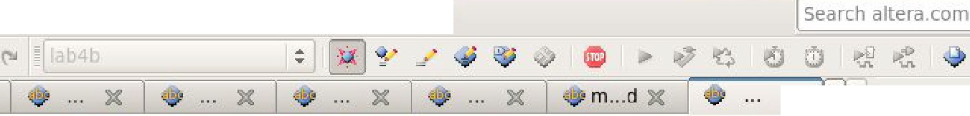

|  |  |  |  |
| --- | --- | --- | --- |
| · | STB.vw f | *157* | *CLRPC,* |
| ·· | LD A.11wf | *158* | *ClJc,* |
| · | LD B.11w f | *15,* | ***I NC_ PC ,.*** |
| ·· | LUl.11wf | *160* | ***LZE _ out _ PC ,.*** |
| JMP.vwf | | *161*  *162* | *ADDR_ OUT*  *) ;* |
| . ·· | ADD.vwf | *163* |  |
| L. | ADDl.vwf | *164* | ***LZE_ A_ Mux : LZE port* m p***(* |

Quartus

II **64-Bit** - /home/ stu dentl /d

ab 4b/l ab 4b - lab4b _ □ **x**

f ile _!;d i t '\,"i ew _!:'r eject !'o

,ssi

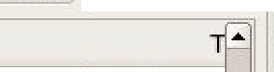

zh an g/COE60B/l

:o

Project Navigator

1. **X**

gnments Processing I ools indow !:!elp '9

)(

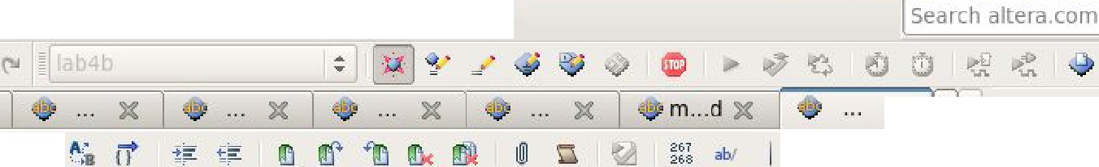

.,

'. **mi**

**X** IP Cat... 1/- [!!1

... § ,_,, **x** I-=

;i;a;;;a:=d=d=e=r =3 .2= v==h= d ========

;::;:;1

**1 9**-**4** - -f- - - - - - - - - - - - - - - - - - - - - - - - - - - - - - =='"' B ***J'o*** ln IJlled Ir

_ a lu. v h d A

**195** El

***H6***

*.Re_ g B : r e gi st e r 3 2 port map(* $ - Project o·

*B_ Mux _ out ,.* · No Sele

j§a f ulladd.vhd

197

*Ld _ B,*

B· **Library**

* da ta_mem. v hd
  + LZE.11hd

.. UZ .E v h d

* RED. v h d

.. mux4to1.vhd

ffLil Data_Path vhd

- LDAl.vwf LDBl.vwf

|  |  |  |
| --- | --- | --- |
| - | STA.v wf | ***208*** |
| · | STB.vw f | *209* |
| ·· | LDA.vwf | *210* |
| · | LDB.vw f | 211 |
| ·· | LUl.vwf | *212* |
|  | JMP.vwf | *213*  ***214*** |

, ·· ADD.vw f

L. ADD l.vw f

@ Hierarchy Fi les • ►

Tasks

Flow: j Custom ize...

I

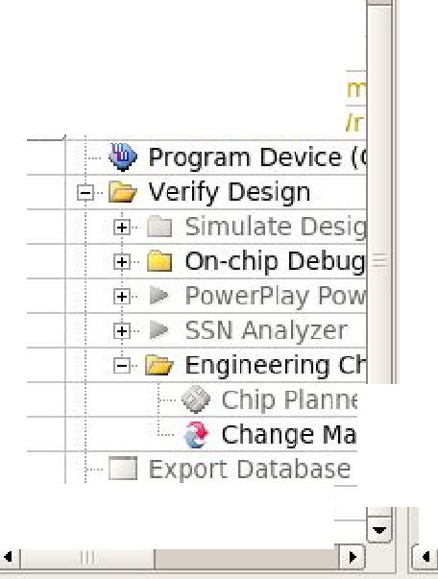

t

**(E %**

- ► Comp ile Design

1B ► Ana lysis & Syn

$ ► Fitter IPl ace &

1B ► Assemb ler (Ge

**0%** l±J..► EDA Netlist Wr

$· ► TimeQuest Ti

***224***

***225***

***226***

*227*

***228***

*229*

*230*

*231*

*232*

*233*

***234***

***235***

*236*

*237*

***238***

***239***

***240***

***241***

***242***

***243***

***244***

l

El

*I M_ MUXl a : mux2tol* port maip *(*

*I H _ MUXl ,*

*r eg _ A_ out, UZJl_ I H_ MUXl _ out ,. I H _ MUXl _ out*

*) ;*

El

l

El

l

***LZE_ I M_ MUX2 :*** *LZE pc,rt map (*

*I R_ out ,.*

*L ZE_ I H_ MUX2 _ out*

*) ;*

*I M_ MUX2a : mux4tol* port maip *(*

*I H _ MUXZ ,*

*r eg _ B_ out , LZE_ I H_ MUX2 _ out ,. ('temp* & *' l ! ) ,- ( ot h er s => ' 0 ' ) , I M_ MUXZ_ out*

*)* ;

Chip Planne

El

:.... □ Archi ve Project

*ALUO : ALU port* ***m.op*** *(*

*I H_ MUXl _* out , *I H_ MUX2 _* out ,. *ALU _ OP ,*

*ALU_ out ,*

~~"'~~

l•I II I l •l

+ Add...

60% ,::, 00 :03 :50

***198***

1n

*200*

*201*

*202*

l

*203* El

***204***

***205***

***206***

*207*

El

l

***215*** El

*216*

217

*218*

2H

***220***

*221*

***222***

*223*

,; -n, l± l Bas_ f,

*r e g-_ B _ <>ut* ©· D5P

J ; Ill l 7 te r'

*.Re t'l'_ HuxO : mux2tol port map(* , .. emoP

- IH Process

*RE_G MUX,* <,earch for

*Reg _ A_* out,. *Reg_ B_* out,.

*Reg _Mux _ out*

*)* ;

*.RRD _ Dat a _ Mem : RED port map(*

*I R_ OUT ,*

*RED_* out _ *dat a_ mem*

*) ;*

*D11t a _ MemO: dll t a _ mem port mzJP (*

*mClk,.*

*RED_* out _ *dat a_ mem ., Reg _Mux _ out .,.*

*WEN ,*

*EN ,*

*dat a_ mem_ out*

*)* ;

Quartus d32zhang/COE608/lab4b/lab4b - lab4b _ c **x**

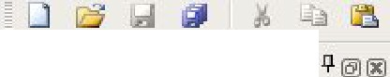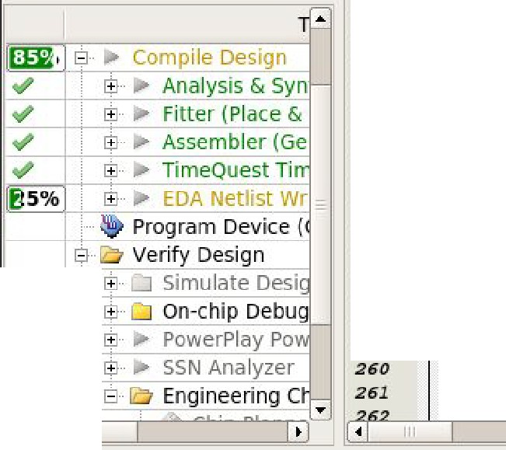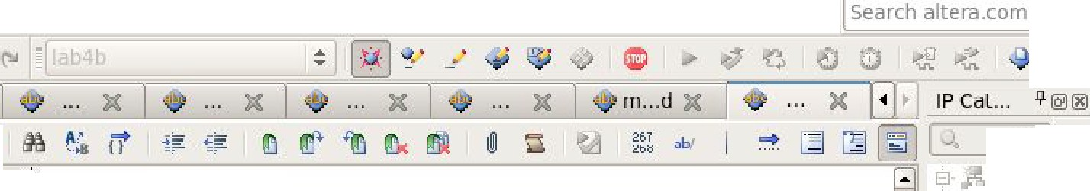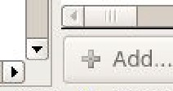

f ile !; dIt \,"1ew £ roJect [\ ss1gnmen ts

Project Navigato r

..,

)(

Processing J ools '!','mdow Hel p

*221*

*222*

*223*

***224***

***22!5***

*226*

*227*

*228*

*229*

*230*

*231*

*232*

*233*

***234***

*23!5*

***d.cit a_m em _ out***

*) ;*

l

El

***I M_ HUXl a : mux2tol port map*** *(*

***I M_ MUXl. ,.***

***r eg _ A_ out , UZE_ I M_ MUXl _ out , I H_ MUXl._ out***

*) ;*

El

l

El

l

*LZE _ I M_ MUX2 : LZE port* ***mnp*** *(*

***I R_ out ,.***

***L ZE_ I M_ HUX2_ out***

*) ;*

**x** I =.

nstal ed IF

8 **Project D"**

o Sele

8 **Library**

1±1- **Bas'" Fl**

© D5P

©· lrter',c

©·Menor

[El Process

* '>edrc for

1

***I M_ HUX2 a : mux4tol port map*** *(*

, *239*

*) ;*

***240***

" *241*

El

Flow:

! J Customize...

*242*

***243***

***244***

***24!5***

***246***

***247***

***248***

***249***

*2!50*

*2!51*

*2!52*

*2!53*

***2!54***

***2!5!5***

*2!56*

*2!57*

***2!58***

***2!59***

*AL CJ0 : AL CJ port =p (*

***I M_ MUXl _ out ,. I M_ MUXZ _* out , *ALCJ_ O,P***

***ALU_ out ,. zer o _ f l a g ,***

***car r y _ f l a g***

*);*

El

***DATA_ MUX O:* mux4tol *port mnp (***

***DATA_ MUX ,***

***DATA_IN,. dllta_mem _out,. ALU_out,. (others => ' O') ,. dllta_bus_s***

*);*

***DATA_ BUS <= da t a_ bus _ s ;***

**end *Be h avi or ;***

l•l

Ill

85 % ' 00 :04:0 9

Fi les ◄ ►

ll @®

/e) Hierarchy

Tasks

ii adder 32.vhd al u.vhd

fu lladd.vhd data_ mem.vhd LZE.vhd UZE.vhd

RED. vhd

mux4to l .vhd

* .( Data_Pat h vhd
  + LDAl.vwf LDB l.vw f

- STA.vwf

·

-

·

-

)(

II **64-Bit** - /home/student

|  |  |  |  |
| --- | --- | --- | --- |
|  | STB.v wf | *236* | ***I M_ MUX2 ,.*** |
| * · | LDA.vwf | *237* | ***reg _B_out, LZE_IM _MUX2_out , (temp* & *'l'),. ( ot hers => ' 0'),.*** |
| L.. ., | LDB.vwf | *238* | ***I H _ MUX2 _ out*** |

# H ow does this data-path implement the INCA, ADDI, LDBI and LDA

o perations?

For INCA operation, we first load LD_A,LD_C,LD_Z, assign A MUX to 0, Data MUX to 10, IM_MUX1 TO 0, IM_MUX2 to 10, and then go to the operation code “010” in alu, alu calculates the assigned value to produce the result.

For ADDI operation, we first load LD_A,LD_C,LD_Z, assign A MUX to 0, Data MUX to 10, IM_MUX1 TO 0, IM_MUX2 to 01, and then go to the operation code “010” in alu, alu calculates the assigned value to produce the result.

For LDBI operation, we first load LD_B, assign B MUX to 1.

For ADDI operation, we first load LD_A, assign EN to 1, assign WEN to 0, assign A MUX to 0, and Data MUX to 01.

# T he data-path has a maximum reliable operating speed (Clk). What

d etermines this speed? (i.e. how would you estimate the data-path c ircuit clock)?

Delays determine the maximum reliable operating speed, every time a different input was passed in, the corresponding result was generated with some delays, delays may be different than others.

# W hat is a reliable limit for you data-path clock?

The reliable limit for my data-path clock was 8.806.

# L DAI.vwf

1. 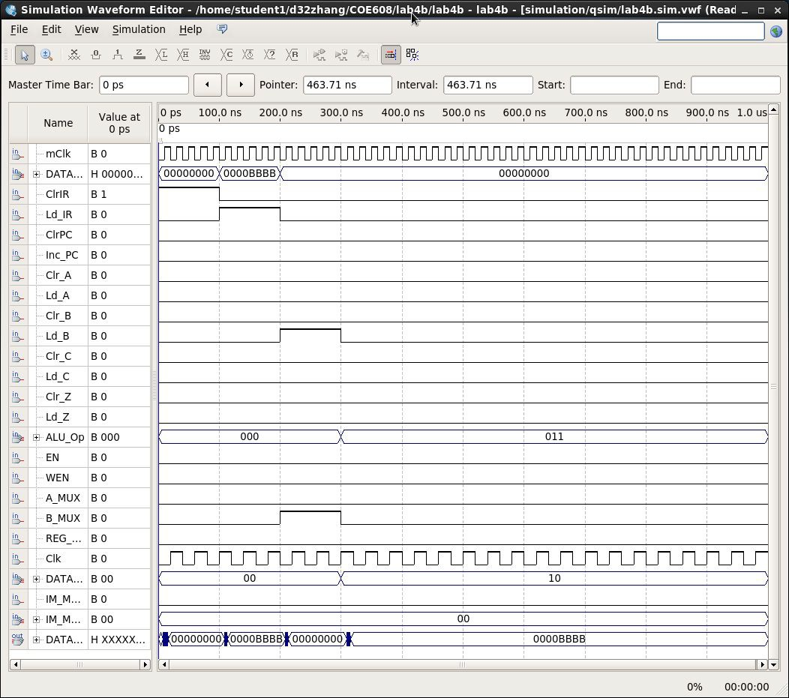L DBI.vwf
2. 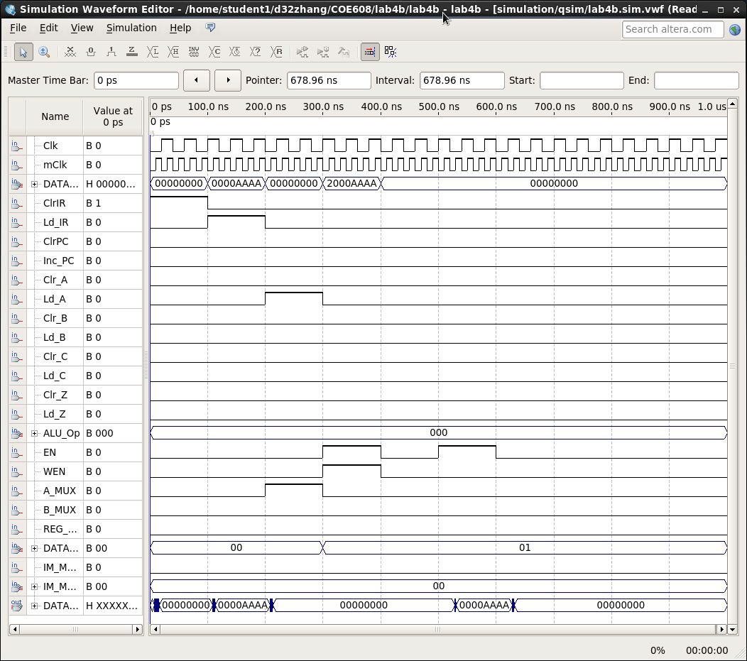S TA.vwf
3. 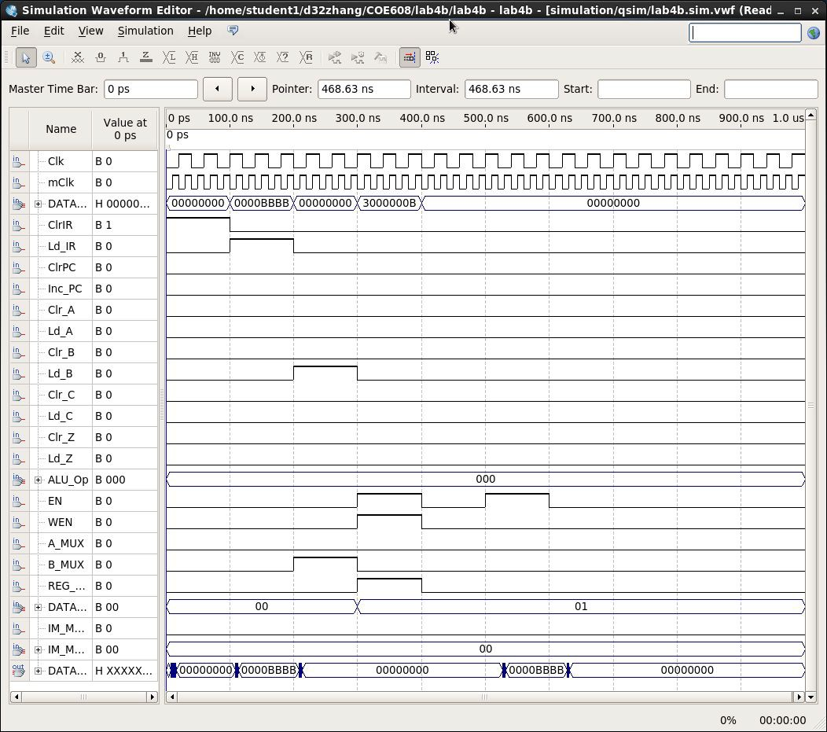S TB.vwf
4. 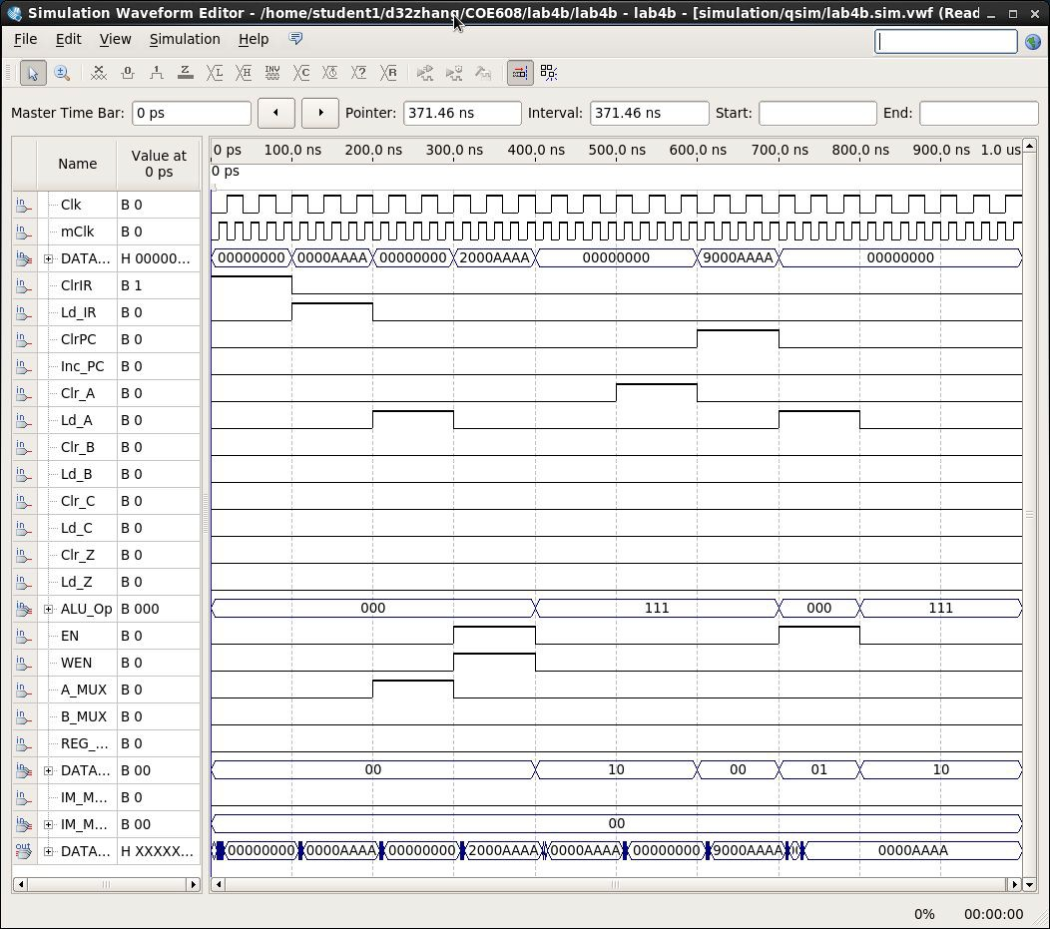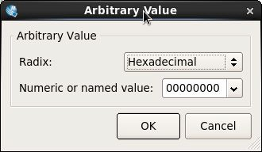L DA.vwf
5. 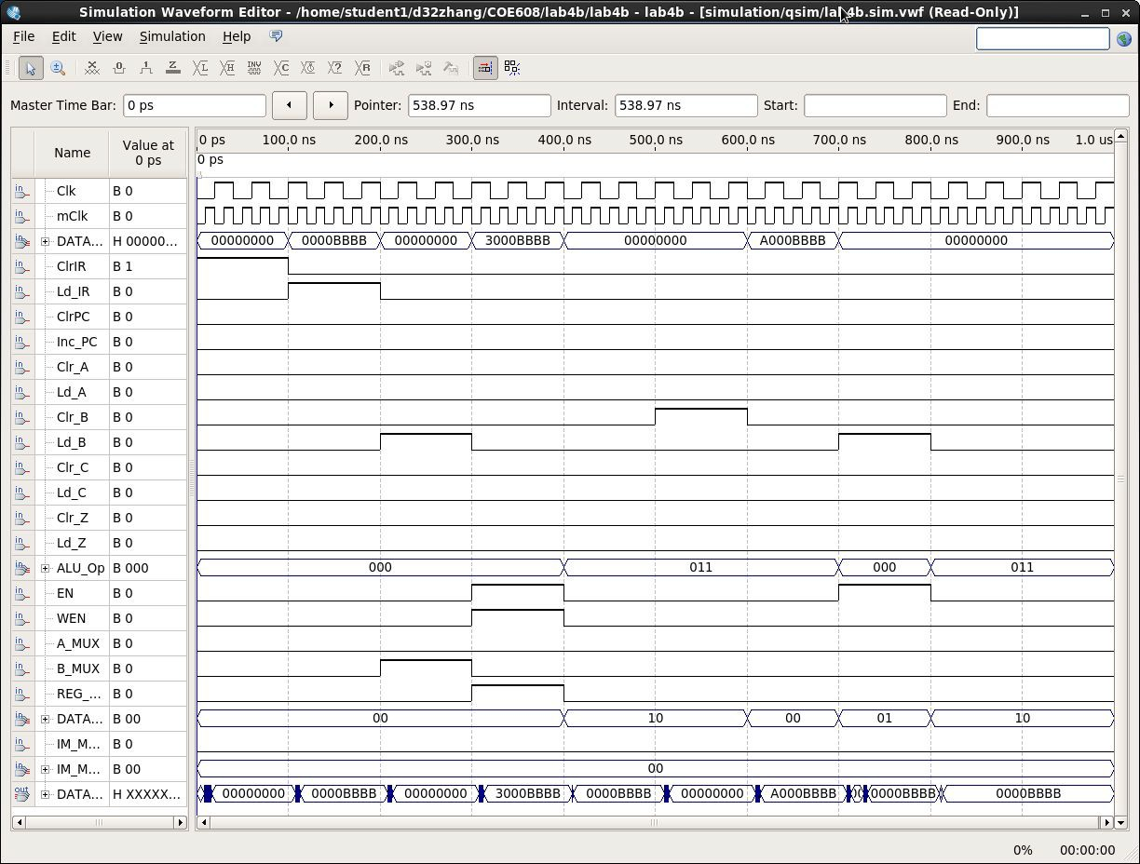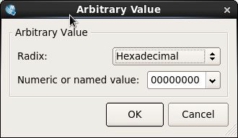L DB
6. 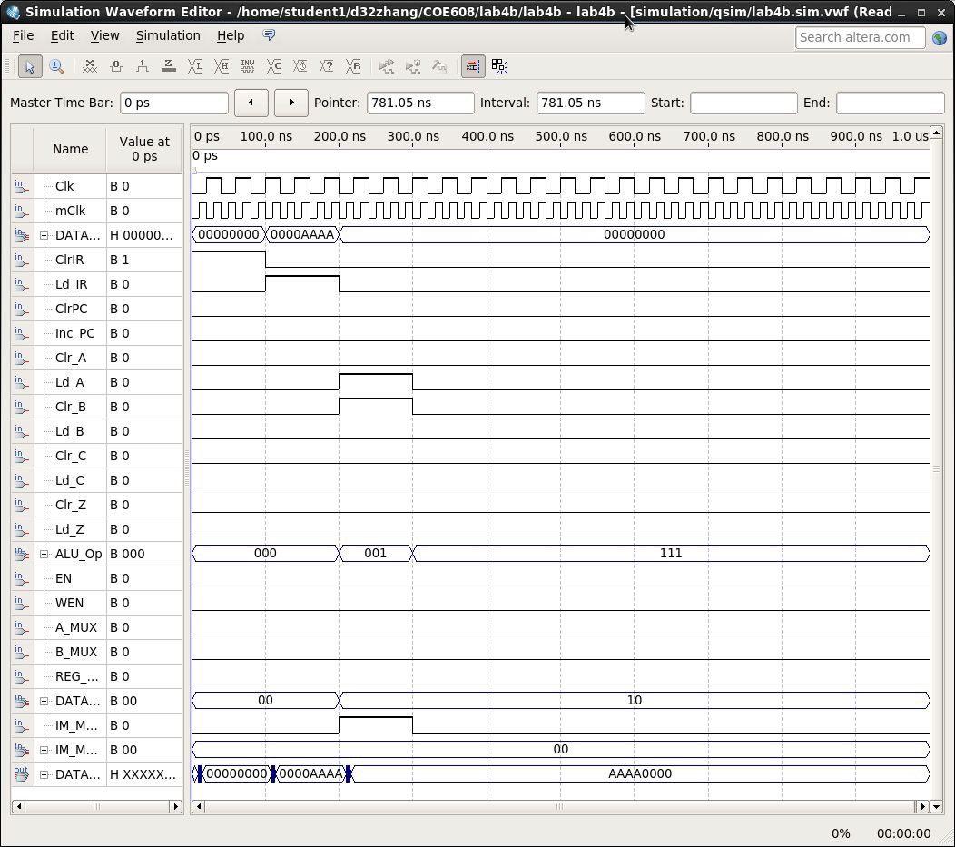L UI
7. 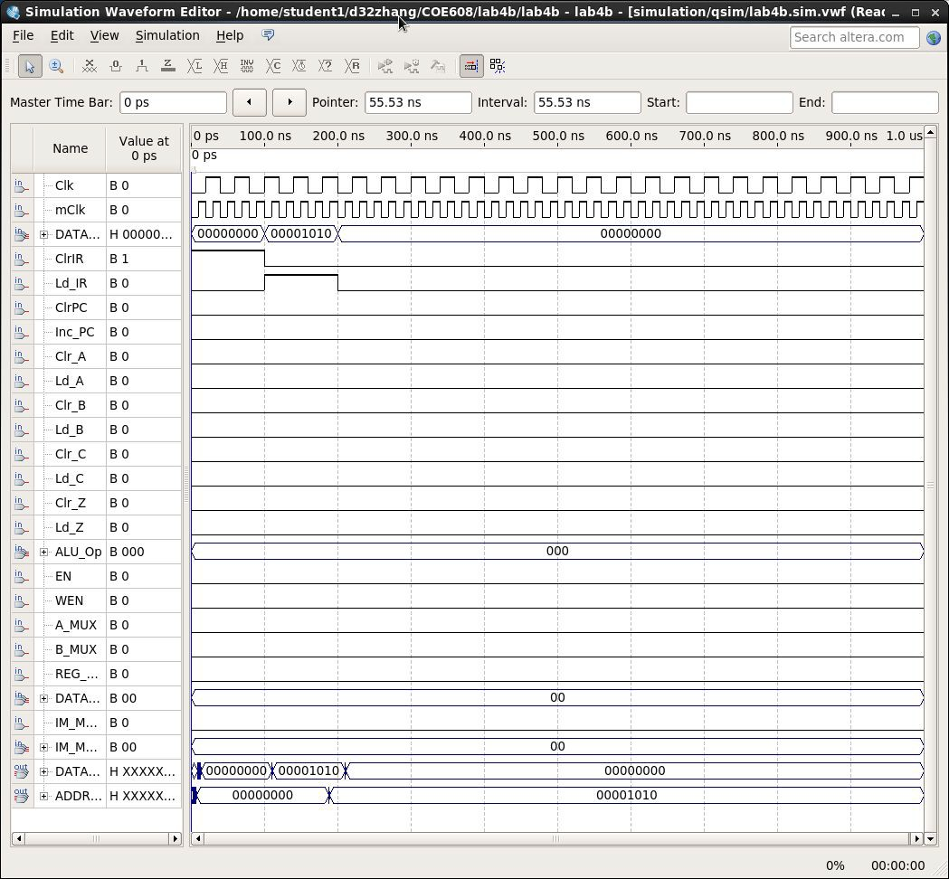J MP
8. 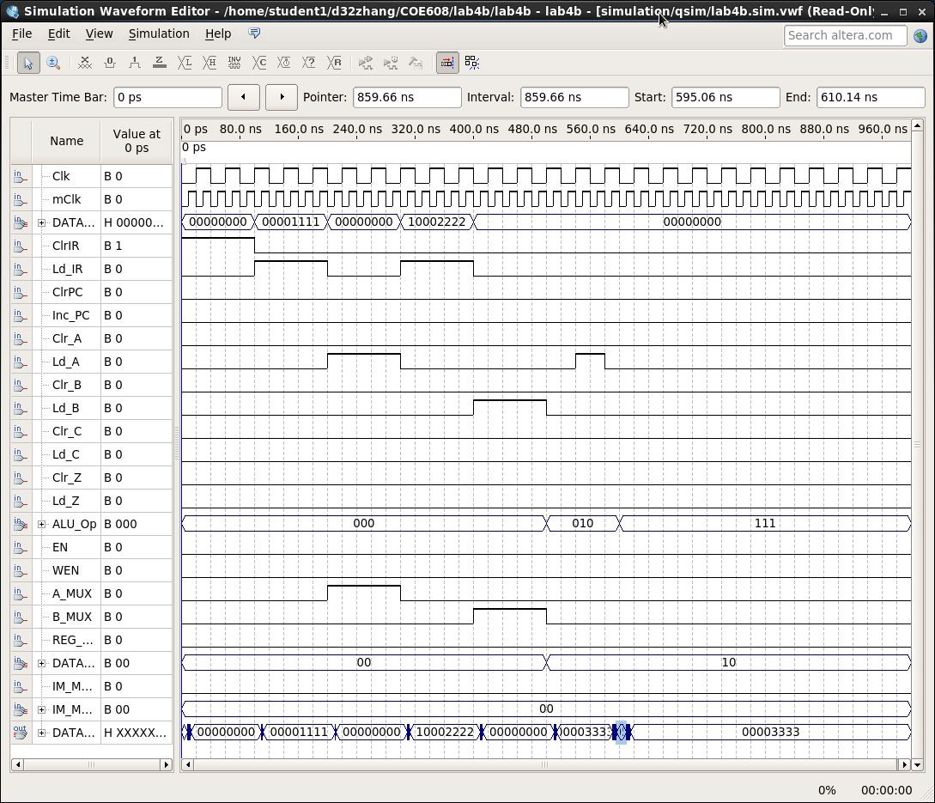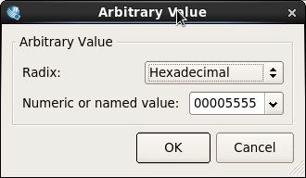A DD
9. 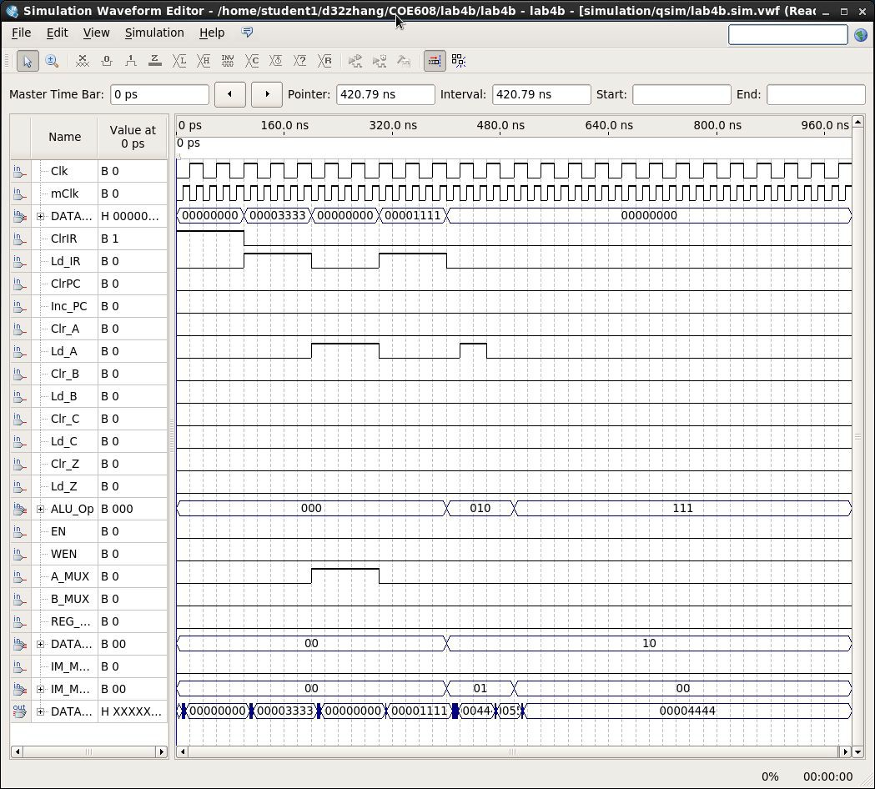A DDI

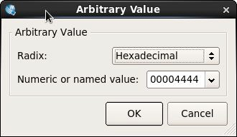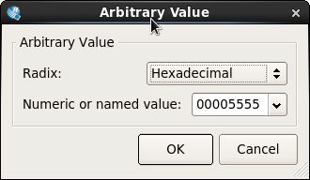

1. 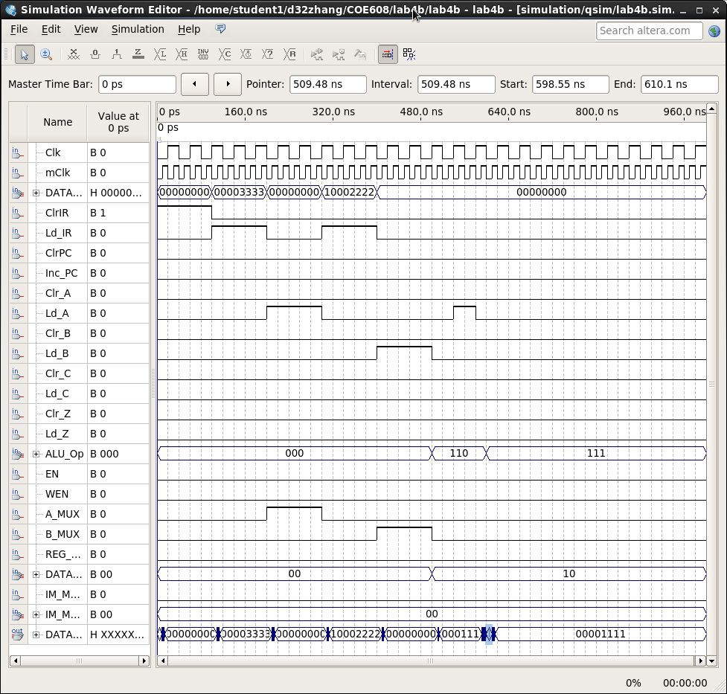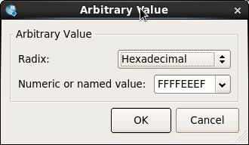S UB
2. 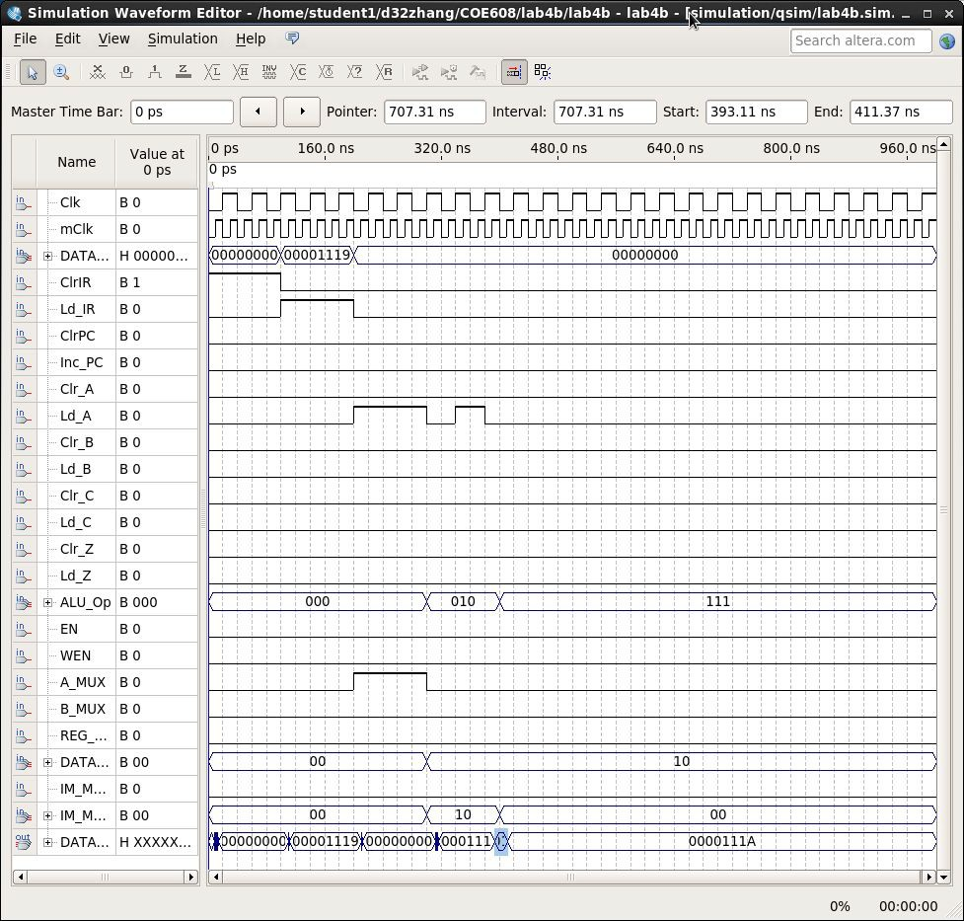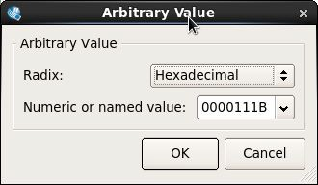I NCA
3. 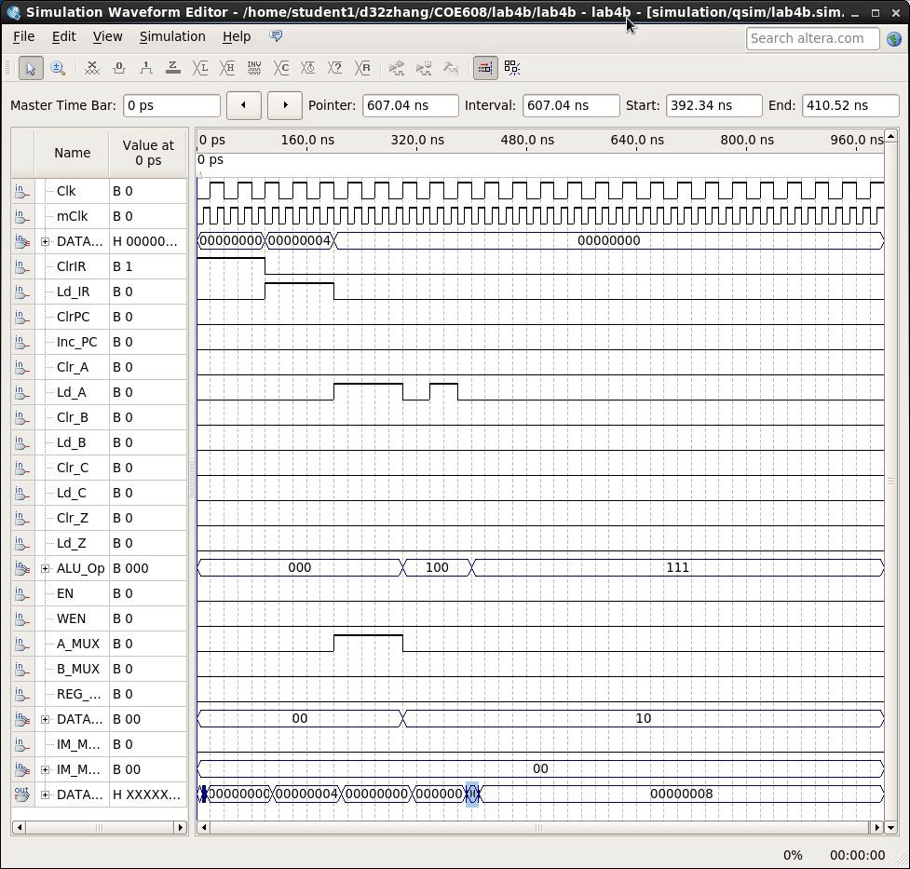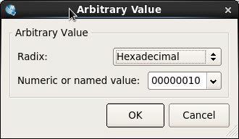R OL
4. 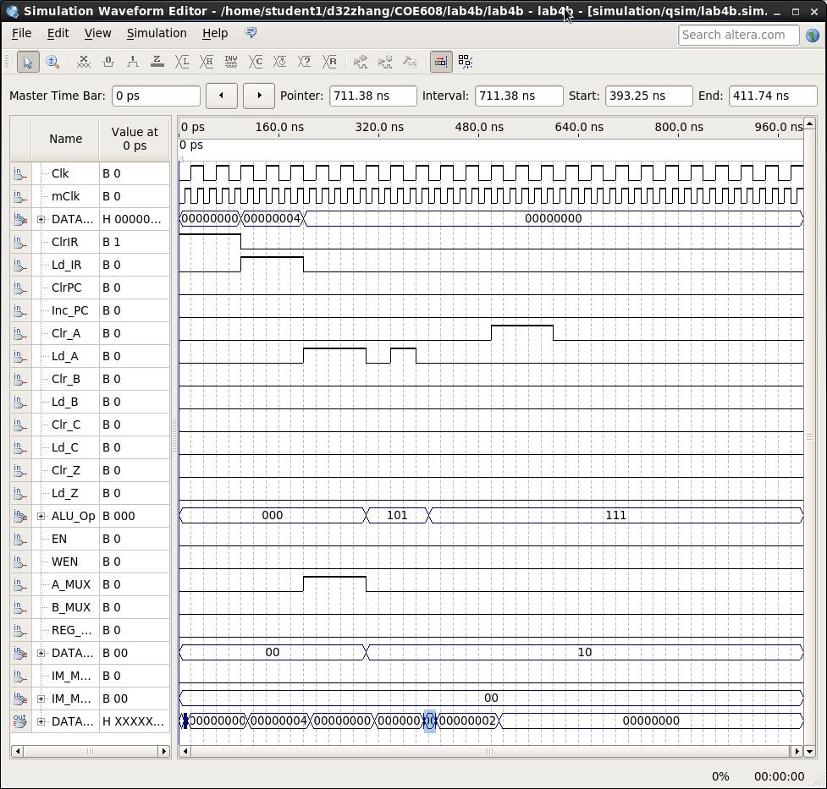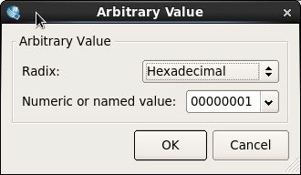C LRA
5. 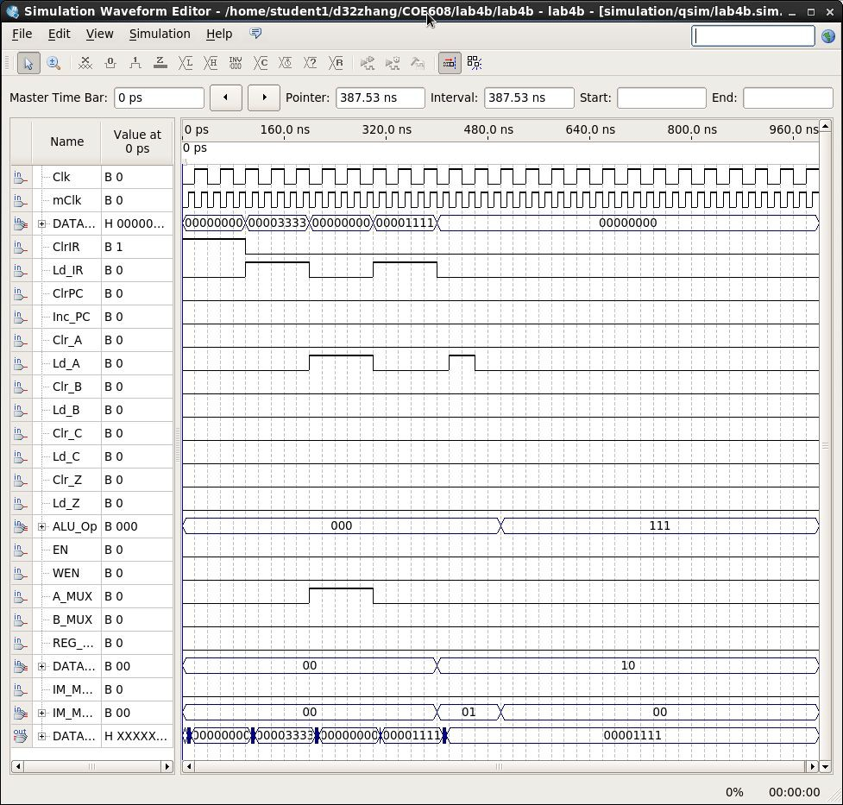A NDI
6. 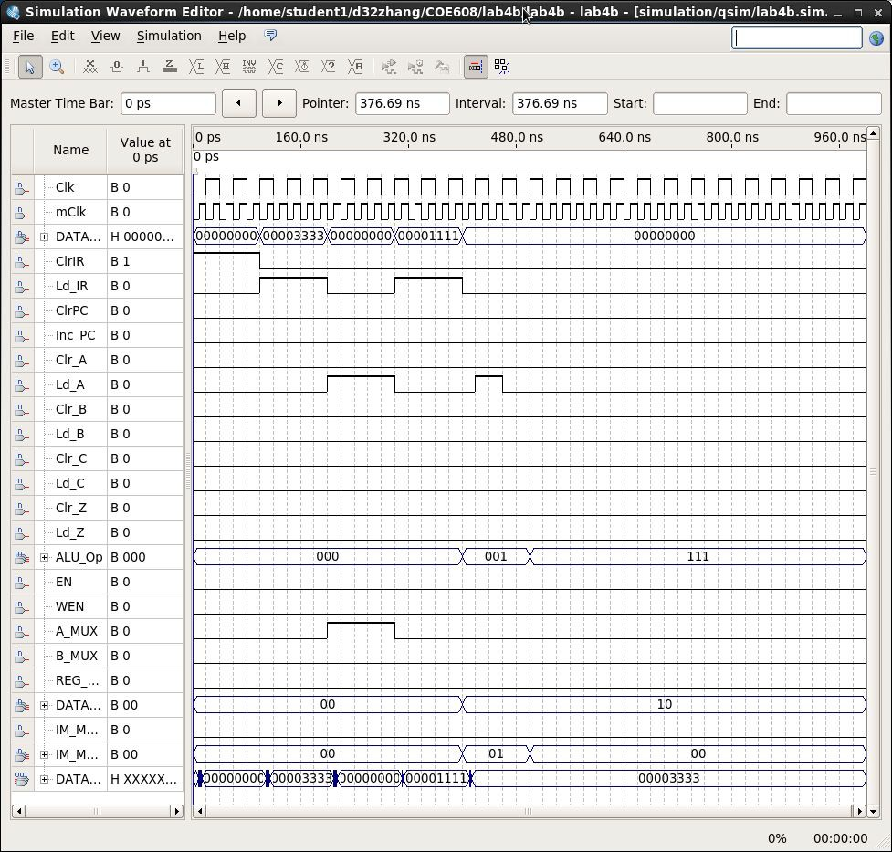O RI
7. 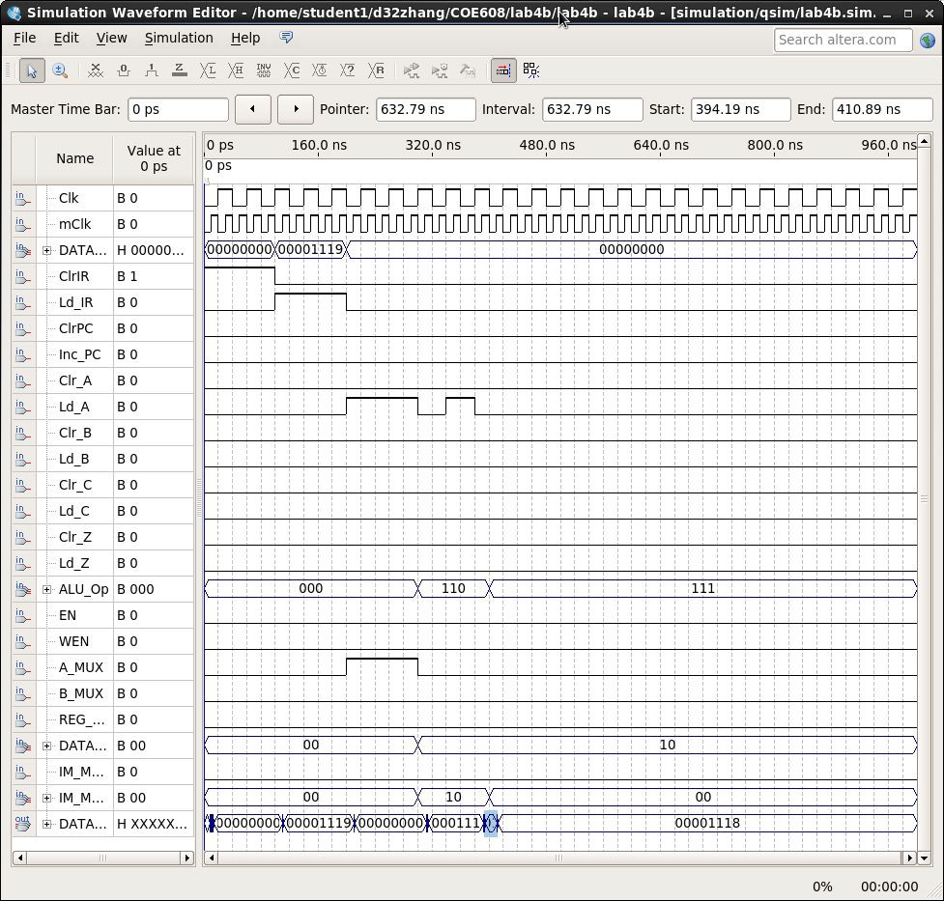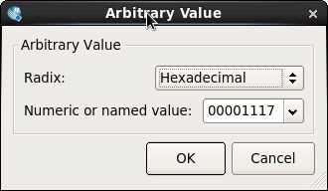D ECA
8. 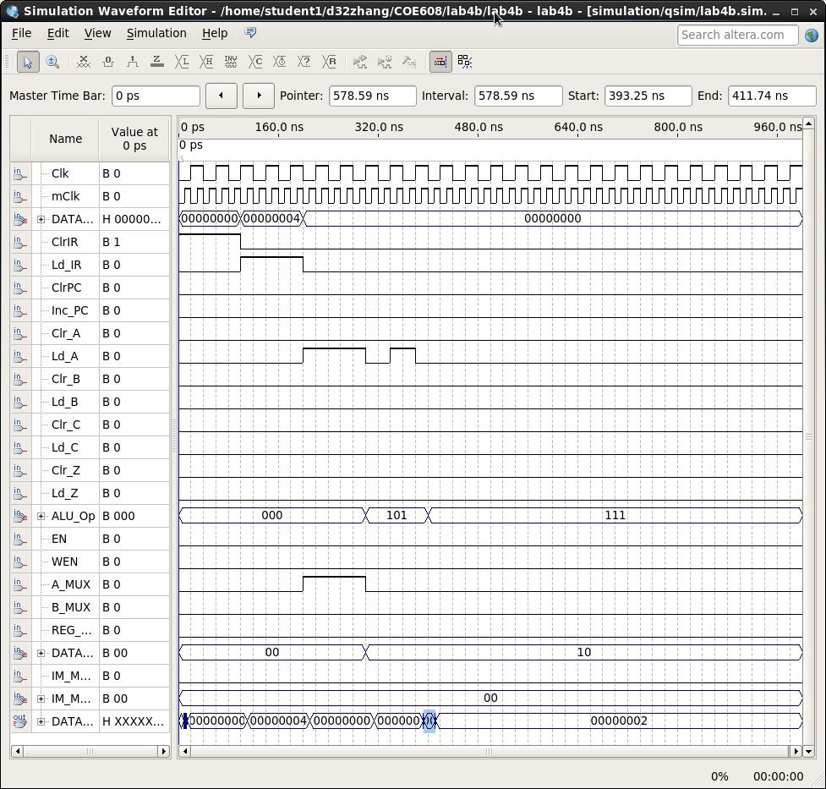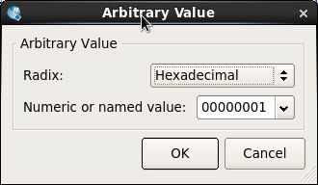R OR

Student ame: fJ\..t.O..f'\W , ru,

Student#: S"OO<a-1.LJ.Q05 Section: *O LI*

***Tabi -***

|  |  |  |  |  |  |  |  |  |  |  |  |  |
| --- | --- | --- | --- | --- | --- | --- | --- | --- | --- | --- | --- | --- |
| *I ST* | **CLR_IR**  **LD _lR** | **LD_PC INC PC** | **CLR A LD A** | **CLR_B LD B** | **CLR_C LD C** | **CLR_Z LD _Z** | **ALU**  **OP** | **EN**  **WEN** | **A/B**  **M UX** | **REG MUX** | **Data MUX** | **IM _M UX I**  **IM _MUX2** |
| **LOA** | *olc* | 0/CJ | 0/ \ | O/o | *O{o* | *o /o* | **XX)<** | *Vo* | o/)':. | 'Y | 01 | ;<l- |
| **LD B** | 0/Q | *Ot u* | o/o | *of* | *<::-(c* | *o/o* | ***)O()<*** | f / o | Y/o | *'f* | Cl |
| **STA** | 10 | O/o | **0/0** | **0/0** | *clc* | *0/0* | ***XX'><*** | 1 / \ |  | 0 | )< | )( |
| **STB** | C/o | *via* | 0/0, | *clc* | *o/O* | ***C(Q*** | *"rY..y* | t/ *I* | **X** | I | x | )<I  L_ |
| **JMP** | ***0(0*** | 1/ 0 | *'0/0* | c.,/Q | *O/C* | 0/ | **)<yX** | **y** | )( | *7'* | )< | *X* |
| **LDAI** | **o/o** | 0/0 | o/\ | *o /Q* | *0!(0* | *0 / (j* | xX)< | y | *\Jx* | / | *J-* | *><* |
| **LDBI** | *0 ( o* | 0/ 0 | 0/ 0 | *o/ (* | *o/o* | o/0 | *)o<X* | *")<* | vi | :x | *y.* | X |
| LUI | o/o | *o(o* | C/1 | *(* /0 | 0/ O | *0 /o* | *o o )* | *')::* | *C!x* | )< | ( 0 | \/x |
| **ANDI** | **o/o** | *C/ ()* | o/r | *0/Q* | 0./j | o/ I | *0\!! 0* | *y* | *0/X* | "/- | 10 | 0/0-/ |
| **DECA** | *c/o* | c/o | 0/1 | *c/o* | 0/( | 0/1 | I *I* G | )< | *Ch<* | 'y | l o | *0110* |
| **ADD** | c/n | ·-/0 | 0/\ | 0/0 | 0/( | 0/1 | 010 | **X** | **C/'X** | **x** | (0 | O/oo |
| **SUB** | *o(C* | *c(o* | O/1 | O/o | 0/\ | 0/1 | \ *I* 0 | **X** | o/X | y | *(* C, | C/Oo |
| **INCA** | *C/0* | *r-/o* | 0/1 | 0/0 | 0/1 | *a//* | 010 | > | O/X | y | 10 | o /! e |
| **AND** | *0(0* | *o(O* | ***Of\***  en | **0/0** | *D/* ( | *0 /(* | ooo | y | *o)x* | X | !O | C/ o |
| **ADD.I** | ***U/0*** | ***0(0*** |  | **0/0** | 0/1 | or r | **0/0** | y | c/x | *\(* | lQ | *o!o* I |
| **ORI** | **0/0** | *O(O* | **D/j** | **o/O** | *or/* | *o/r* | Do I | 'y | *o/x* | ***'I<'*** | *le* | *Oj Of* |
| ROL | 0/O | 0/0 | o/1 | *o*,o*la*- | *of* | 0/( | fGJ!O | y | *Dix* | X | *( Q* | *01?z-* |
| ROR | 0/0 | o/O | *9((* |  | 0/1 | 0/1 | 10 I | y | OfY. | *><* | *1n* | 0  ·- |
| CLRA | *o/0* | *01/0* | t/G | *O/O* | 0/& | *fJ/Q* | X))c | X | *)<* | *y* | X | ¥.j |
| CLRB | CJ/o | *o/O* | */0* | 1/o | *oto* | *o/o* | Y)(J.. | **X** | *>-* | y | *7'* | *I* |
| CLRC | 0/0 | *C(o* | *0/O* | 0/0 | I/ d | *0/0* | *XX)<* | >' | *)<* | *7'* | *)<* | ·-  X |
| CLRZ | o;o | *o/o* | */o* | *o/()* | *r:Y/<P* | *Vo* | )«')( | )<. | **X** | x | X | Y-, |
| PC<=  **PC+4** | *0(0* | I/ I | 4-1 | *f:Y{O* | *o(o* | ofo | )()(X | **X** | y | y | X | *"I...* |
| IR<=  **M[INSTJ** | *of,* | 0/0 | O/o | *ofa* | 0/g | *O/o* |  |  | *'7* | )( | *Oo* | *x* |
| **PC<= IR[IS..O]** | 0/rj | //0 | *ul/o* | e>/,o' | , (!)I, | 0/Q | * | X | ***X*** | 'X | *>--* | x |